ASSIGNMENT 1
Q1 Input :-
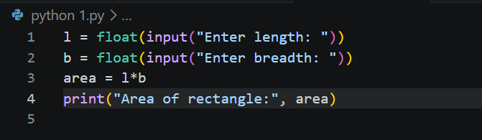
Output:-
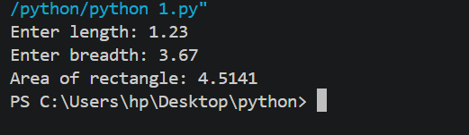
Q2 Input:-
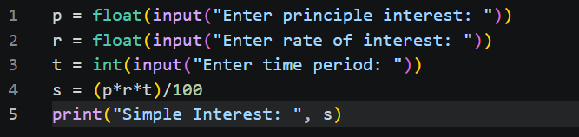
Output:-
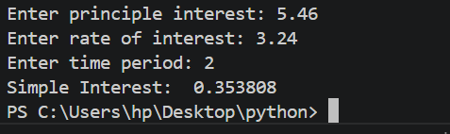
Q3 Input:-
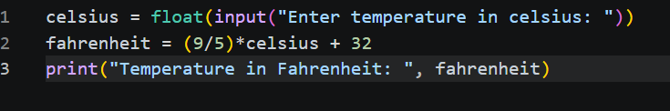
Output:-
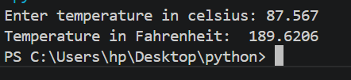
Q4 Input:-
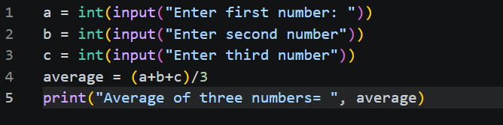
Output:-
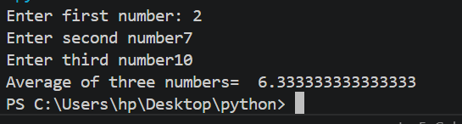
Q5 Input:-
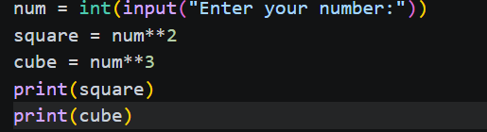
Output:-
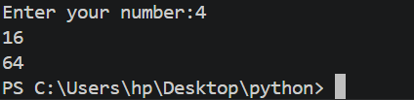
Q6 Input:-
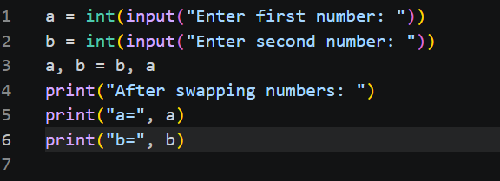
Output:-
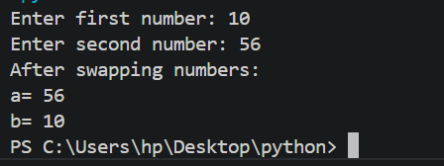
Q7 Input:-
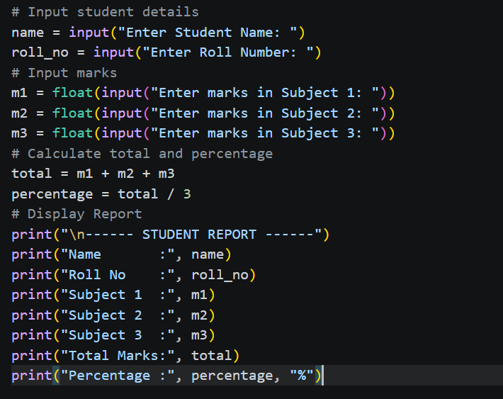
Output:-
